**Databases Assignment**

**Group Number: A13-G4**

**Tutor Name: Anthony Kleerekoper**

**Umair Rehman (21343766)**

**Benjamin Ajayi (21361114)**

**Yves Niyo (21364033)**

**Aaron Oronsaye (21336343)**

**Table of Contents**

Section 1: Executive Summary 3

Section 2: Database Design 7

4a - Top Down ERD 7

4b - Normalisation and Bottom Up ERD 8

4c - Merge of Top Down and Bottom Up ERD’s 10

Section 5: SQL Implementation 11

5a - Drop and Create Statements 11

5b - Insert & Select Statements 12

Section 7: Student Statements 14

Student A – Name and ID 14

Student B – Name and ID 14

Student C – Name and ID 14

Student D – Name and ID 14

Appendix A: Individual ERD Attempts 16

Appendix B: Logbook 17

Appendix C: Full SQL Code 18

# Section 1 - Executive Summary

*Produce an executive summary giving readers an overview of your report and including the below information.*

* 1. *purpose (one or two sentences explaining the purpose of your report);*
  2. *background (one sentence explaining what Mike’s Motorboats does);*
  3. *problem statement (one paragraph stating the main issues with the current system);*
  4. *summary of contents of report (one paragraph/two sentences)*

*This is the first thing the readers of your report will read, but the last thing you should write. Should be in third person, no use of I, we etc.*

A – The purpose of the report was to evidently document the creation of the database of the boat renting/reserving business.

B – Mike’s Motorboat is a boat renting business, and they also take reservations.

C – The main issues with the current system is that it was paper based so it was hard to maintain. When spreadsheets and database was introduced the system failed to distinguish between rental and reservation causing confusion between staff and customers.

D – In this report, we included images of our individual ERDs and our combined final ERD. We also included the SQL code that we combined together from our individual SQL scripts which we then after debugged to make sure that it ran without errors.

# Section 2: Database Design

## 2a - Top Down ERD

*Insert your finalised GROUP top down ERD here. Provide a written commentary explaining any decisions made in moving from the individual diagrams to the group one. The commentary should list any assumptions you have made.*

*Make sure diagram is readable and colours do not clash with the text*

*An individual entity relationship diagram (ERD) should be drawn by each member of the group. These need to be placed into the appendix of your report to provide evidence of participation, without these you will lose marks. Each one should have a student name/number associated with it. They must all be different.*

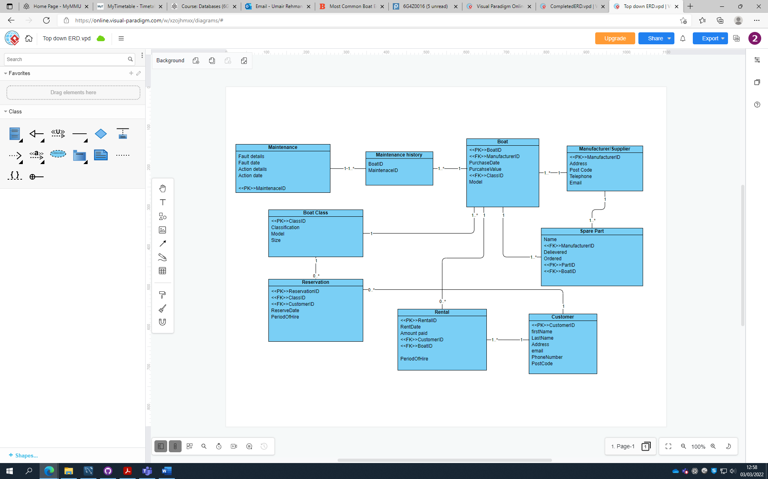

## 2b - Bottom Up ERD

**Boat Record Normalisation**

*Normalise the boat record showing all stages of the normalisation process (UNF, 1NF, 2NF, 3NF). Use Excel and copy paste in your tables here.*

|  |  |  |  |  |  |  |  |  |  |  |  |  |
| --- | --- | --- | --- | --- | --- | --- | --- | --- | --- | --- | --- | --- |
| Appendix A | | UNF |  |  | 1NF |  |  | 2NF |  |  | 3NF |  |
|  |  | **Boat Number** | |  | **Boat Number** | |  | **Boat Number** | |  | **Boat Number** | |
|  |  | Model |  |  | Model |  |  | Model |  |  | Model |  |
|  |  | Purchase date | |  | Purchase date | |  | Purchase date | |  | Purchase date | |
|  |  | Purchase Price | |  | Purchase Price | |  | Purchase Price | |  | Purchase Price | |
|  |  | Class |  |  | Class |  |  | Class |  |  | Class |  |
|  |  | Size |  |  | Size |  |  | Size |  |  | Size |  |
|  |  | Manufacturer | |  | Manufacturer | |  | Manufacturer | |  | Manufacturer* | |
|  |  | ManAddress | |  | ManAddress | |  | ManAddress | |  |  |  |
|  |  | ManPostcode | |  | ManPostcode | |  | ManPostcode | |  | **Manufacturer** | |
|  |  | ManTelephone | |  | ManTelephone | |  | ManTelephone | |  | ManAddress | |
|  |  | ManEmail | |  | ManEmail | |  | ManEmail | |  | ManPostcode | |
|  |  | DispSaleDate | |  | DispSaleDate | |  | DispSaleDate | |  | ManTelephone | |
|  |  | DispDealerName | |  | DispDealerName | |  | DispDealerName | |  | ManEmail | |
|  |  | DispAddress | |  | DispAddress | |  | DispAddress | |  |  |  |
|  |  | DispTelephone | |  | DispTelephone | |  | DispTelephone | |  | **DisposalID** | |
|  |  | DispEmail | |  | DispEmail | |  | DispEmail | |  | DispSaleDate | |
|  |  | DispSalePrice | |  | DispSalePrice | |  | DispSalePrice | |  | DispSalePrice | |
|  |  | MaintRefNo | |  |  |  |  |  |  |  | DealerID* | |
|  |  | MaintFaultDetails | |  | **Boat Number** | |  | **Boat Number** | |  | Boat Number* | |
|  |  | MaintFaultDate | |  | **MaintRefNo** | |  | **MaintRefNo** | |  |  |  |
|  |  | MaintActionTaken | |  | MaintFaultDetails | |  | MaintFaultDetails | |  | **DealerID** |  |
|  |  | MaintActionDate | |  | MaintFaultDate | |  | MaintFaultDate | |  | DispDealerName | |
|  |  |  |  |  | MaintActionTaken | |  | MaintActionTaken | |  | DispAddress | |
|  |  |  |  |  | MaintActionDate | |  | MaintActionDate | |  | DispTelephone | |
|  |  |  |  |  |  |  |  |  |  |  | DispEmail | |
|  |  |  |  |  |  |  |  |  |  |  |  |  |
|  |  |  |  |  |  |  |  |  |  |  | **Boat Number** | |
|  |  |  |  |  |  |  |  |  |  |  | **MaintRefNo** | |
|  |  |  |  |  |  |  |  |  |  |  | MaintFaultDetails | |
|  |  |  |  |  |  |  |  |  |  |  | MaintFaultDate | |
|  |  |  |  |  |  |  |  |  |  |  | MaintActionTaken | |
|  |  |  |  |  |  |  |  |  |  |  | MaintActionDate | |
|  | |  |  |  |  |  |  |  |  |  |  |  |
|  |  |  | |  |  | |  |  | |  |  | |
|  |  |  |  |  |  |  |  |  |  |  |  |  |
|  |  |  | |  |  | |  |  | |  |  | |
|  |  |  | |  |  | |  |  | |  |  | |
|  |  |  |  |  |  |  |  |  |  |  |  |  |
|  |  |  |  |  |  |  |  |  |  |  |  |  |
|  |  |  | |  |  | |  |  | |  |  | |
|  |  |  | |  |  | |  |  | |  |  |  |
|  |  |  | |  |  | |  |  | |  |  | |
|  |  |  | |  |  | |  |  | |  |  | |
|  |  |  | |  |  | |  |  | |  |  | |
|  |  |  | |  |  | |  |  | |  |  | |
|  |  |  | |  |  | |  |  | |  |  | |
|  |  |  | |  |  | |  |  | |  |  |  |
|  |  |  | |  |  | |  |  | |  |  | |
|  |  |  | |  |  | |  |  | |  |  | |
|  |  |  | |  |  | |  |  | |  |  | |
|  |  |  | |  |  |  |  |  |  |  |  | |
|  |  |  | |  |  | |  |  | |  |  | |
|  |  |  | |  |  | |  |  | |  |  |  |
|  |  |  | |  |  | |  |  | |  |  |  |
|  |  |  | |  |  | |  |  | |  |  | |
|  |  |  |  |  |  | |  |  | |  |  | |
|  |  |  |  |  |  | |  |  | |  |  | |
|  |  |  |  |  |  |  |  |  |  |  |  | |
|  |  |  |  |  |  |  |  |  |  |  |  |  |
|  |  |  |  |  |  |  |  |  |  |  |  | |
|  |  |  |  |  |  |  |  |  |  |  |  | |
|  |  |  |  |  |  |  |  |  |  |  |  | |
|  |  |  |  |  |  |  |  |  |  |  |  | |
|  |  |  |  |  |  |  |  |  |  |  |  | |
|  |  |  |  |  |  |  |  |  |  |  |  | |
|  |  |  |  |  |  |  |  |  |  |  |  |  |

**Merged 3NFs from Normalisations and Bottom Up Data Model**

*Then produce a bottom up ERD from the tables produced at 3NF. Make sure diagram is readable and colours do not clash with the text*

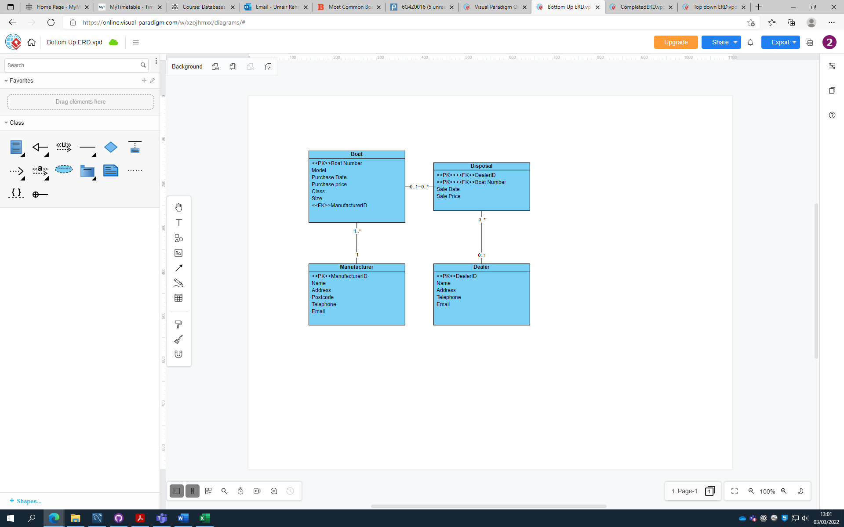

## 2c - Merge of Top Down and Bottom Up ERD’s

*Merge your top down and bottom up data models to produce a final ERD. Make sure diagram is readable and colours do not clash with the text*

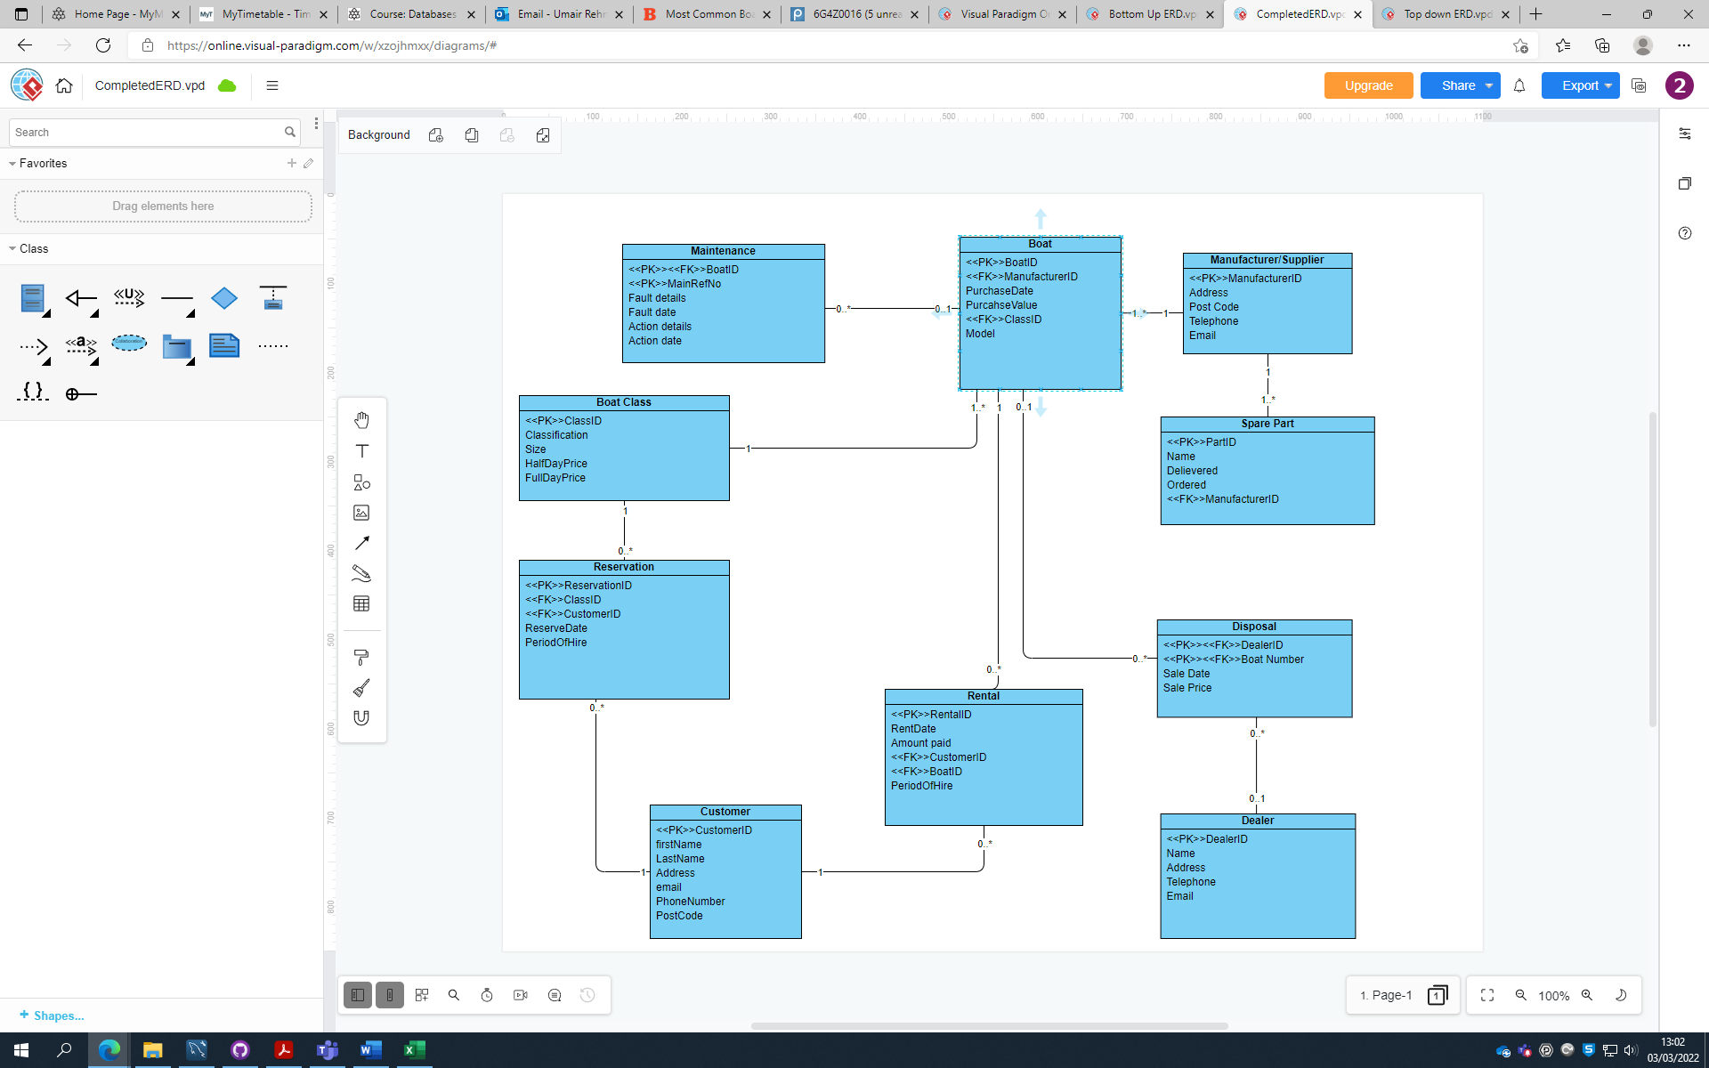

# Section 3: SQL Implementation

## 3a - Drop and Create Statements

*Include the code for all your DROP and CREATE statements.*

/************************************************************************************************************************/

/* Drop tables (if existing) */

DROP TABLE IF EXISTS Disposal;

DROP TABLE IF EXISTS Dealer;

DROP TABLE IF EXISTS Rental;

DROP TABLE IF EXISTS Customer;

DROP TABLE IF EXISTS Reservation;

DROP TABLE IF EXISTS Maintenance;

DROP TABLE IF EXISTS Spare_Part;

DROP TABLE IF EXISTS Boat;

DROP TABLE IF EXISTS Boat_Class;

DROP TABLE IF EXISTS Supplier;

/************************************************************************************************************************/

/* Create Tables */

CREATE TABLE Supplier (

SupplierID INT PRIMARY KEY AUTO_INCREMENT,

SupplierName VARCHAR(50),

Address VARCHAR(50),

PostCode VARCHAR(8),

Telephone VARCHAR(15),

Email VARCHAR(40) UNIQUE

);

create table Boat_Class (

ClassID int primary key auto_increment,

Classification varchar(20) CHECK (Classification IN ("Motor boat", "Row boat", "Sail boat")),

Size varchar(15) CHECK (Size IN ("very large", "large", "standard", "small")),

HalfDayPrice decimal (5,2),

FullDayPrice decimal (5,2)

);

CREATE TABLE Boat (

BoatID INT PRIMARY KEY AUTO_INCREMENT,

SupplierID INT NOT NULL,

ClassID INT,

PurchaseDate DATE,

PurchaseValue DECIMAL(8, 2),

Model VARCHAR(20),

CONSTRAINT FK_BOAT_SUPPLIER_ID FOREIGN KEY (SupplierID) REFERENCES Supplier (SupplierID) ON UPDATE CASCADE,

CONSTRAINT FK_BOAT_CLASS_ID FOREIGN KEY (ClassID) REFERENCES Boat_Class (ClassID) ON UPDATE CASCADE,

CONSTRAINT PURCHASE_VALUE_CHK CHECK (PurchaseValue >= 0)

);

CREATE TABLE Spare_Part (

PartID INT PRIMARY KEY AUTO_INCREMENT,

SupplierID INT NOT NULL,

PartName VARCHAR(10),

Delivered BIT,

Ordered BIT,

CONSTRAINT FK_SPARE_PART_SUPPLIER_ID FOREIGN KEY (SupplierID) REFERENCES Supplier (SupplierID) ON UPDATE CASCADE

);

create table Reservation (

ReservationID int primary key auto_increment,

ClassID int,

CustomerID int,

ReserveDate date,

PeriodOfHire varchar(10),

constraint fk_ClassID foreign key (ClassID) references Boat_Class (ClassID) ON UPDATE CASCADE

);

create table Maintenance (

BoatID int,

MainRefNo int ,

FaultDetails varchar(100),

FaultDate date,

ActionDetails varchar(50),

ActionDate date,

Priority INT DEFAULT 2,

CONSTRAINT primary key (BoatID, MainRefNo),

CONSTRAINT FK_BOAT_ID FOREIGN KEY (BoatID) REFERENCES Boat (BoatID) ON UPDATE CASCADE

);

CREATE TABLE Customer (

CustomerID INT PRIMARY KEY,

First_name VARCHAR(45),

Last_name VARCHAR(45),

Address VARCHAR(45),

Email VARCHAR(45),

Phone_number varchar(15),

Postcode VARCHAR(45)

);

CREATE TABLE Rental (

RentalID INT PRIMARY KEY,

RentDate DATE,

Amount_paid INT,

CustomerID INT,

BoatID INT,

PeriodOfHire DECIMAL(3,1),

CONSTRAINT customer_renting FOREIGN KEY (customerID) REFERENCES Customer(customerID),

CONSTRAINT boat_key FOREIGN KEY(BoatID) REFERENCES Boat (BoatID)

);

create table Dealer (

DealerID int primary key auto_increment,

DealerName varchar(50),

Address varchar(100),

TelephoneNumber varchar(15),

Email varchar(100)

);

create table Disposal (

DealerID int,

BoatNumber int,

SaleDate date,

SalePrice int,

CONSTRAINT primary key (DealerID, BoatNumber),

constraint fk_DealerID foreign key (DealerID) references Dealer (DealerID) ON UPDATE CASCADE

);

/************************************************************************************************************************/

## 3b - Insert Statements

*Include one example SQL INSERT statement for each table in your report.*

INSERT INTO Supplier (SupplierID, SupplierName, Address, PostCode, Telephone, Email) VALUES

(1, "SuperBoat", "Unit 7 Centurion Court, Leyland", "LE10 2DJ", "01772459666", "admin@superboat.co.uk"),

(2, "Explorer Boats UK", "Meadow Lane, Burscough", "BU56 8GH", "01704807654", "admin@explorerboats.co.uk"),

(3, "The Northwich Boat Company", "Unit 1 Kings Lock Boatyard Booth Lane, Middlewich", "MW67 7GY", "01270160160", "admin@northwichboats.co.uk"),

(4, "Collingwood Boat Builders", "29 Townsend Street, Collingwood", "CL27 2DU", "01513742985", "admin@collingwoodboats.co.uk"),

(5, "Elton Moss Boat Builders", "Unit 4 Kings Lock Boatyard Booth Lane, Middlewich", "MW63 8TY", "01270760160", "admin@eltonmossboats.co.uk"),

(6, "Aintree Boat Company Ltd", "Brookfield Drive, Liverpool", "L1 6GU", "01515239000", "admin@aintreeboats.co.uk"),

(7, "Braidbar Boats Ltd", "Lord Vernons Wharf Lyme Road Higher, Poynton", "PY12 9TS", "01625873471", "admin@braidbarboats.co.uk"),

(8, "Bourne Boat Builders Ltd", "Teddesley Road, Penkridge", "PE8 7SU", "01785714692", "admin@bourneboats.co.uk"),

(9, "Stoke on Trent Boat Building Co Ltd", "Longport Wharf Station Street, Stoke-on-Trent", "ST6 9GU", "01782813831", "admin@stokeboats.co.uk"),

(10, "MGM Boats Narrowboat Builders", "27 Mill Lane, Leicester", "LE6 9FY", "01162640009", "admin@mgmboats.co.uk"),

(11, "Zinter Ltd", "13 Lower Chatham Street, Manchester", "M1 5SX", "01262348009", "admin@zinter.co.uk"),

(12, "Speed Shack", "27 Hart Lane, London", "N3 9GW", "01162640009", "admin@speedshack.co.uk"),

(13, "Kayak Verse", "12 Binter Road, Sheffield", "S6 4FV", "02206952396", "admin@kayakverse.co.uk"),

(14, "Aston Boats Ltd", "4 Ulton Road, Leicester", "LE1 3RG", "01762648579", "admin@astonboats.co.uk"),

(15, "Rapid Rowing Ltd", "69 Hilton Drive, Bolton", "LE6 4FO", "08164567869", "admin@rapidrowing.co.uk");

Insert into Boat_Class

(ClassID, Classification, Size, HalfDayPrice, FullDayPrice)

Values (1, 'Sail boat', 'very large', 240, 170),

(2, 'Sail boat', 'large', 180, 120),

(3, 'Sail boat', 'standard', 160, 100),

(4, 'Sail boat', 'small', 140, 90),

(5, 'Motor boat', 'very large', 280, 175),

(6, 'Motor boat', 'large', 240, 150),

(7, 'Motor boat', 'standard', 200, 125 ),

(8, 'Motor boat', 'small', 170, 110),

(9, 'Row boat', 'very large', 160, 100),

(10, 'Row boat', 'large', 140, 90),

(11, 'Row boat', 'standard', 120, 80 ),

(12, 'Row boat', 'small', 110, 70);

INSERT INTO Boat (BoatID, SupplierID, ClassID, PurchaseDate, PurchaseValue, Model) VALUES

(1, 1, 7, "2010-11-22", 3910, "Explorer"),

(2, 2, 1, "2009-10-12", 3840, "TurboSail"),

(3, 2, 2, "2015-10-12", 3240, "MasterSail"),

(4, 3, 4, "2015-11-12", 2040, "SmallSailor"),

(5, 3, 4, "2015-11-12", 2040, "SmallSailor"),

(6, 5, 6, "2015-01-14", 5440, "Grande"),

(7, 5, 6, "2015-01-14", 5440, "Grande"),

(8, 2, 7, "2015-01-14", 5440, "Turbo Mid"),

(9, 3, 10, "2015-01-12", 5440, "RowStream"),

(10, 4, 11, "2015-01-12", 5440, "RowerX"),

(11, 1, 2, "2016-01-10", 5440, "Explorer"),

(12, 1, 3, "2016-01-10", 5440, "Navigator"),

(13, 2, 7, "2018-02-14", 5440, "Turbo Mid"),

(14, 2, 7, "2018-02-14", 5440, "Turbo Mid"),

(15, 7, 6, "2018-01-14", 5440, "MasterBlaster"),

(16, 8, 10, "2018-01-10", 5440, "HappyRower"),

(17, 8, 11, "2018-01-10", 5440, "HappyRower"),

(18, 3, 9, "2017-01-09", 5440, "Streamer"),

(19, 4, 9, "2019-01-19", 5440, "Great Row"),

(20, 7, 5, "2018-01-14", 5440, "SuperBlaster"),

(21, 6, 11, "2017-01-09", 5440, "Lizard"),

(22, 5, 6, "2018-02-14", 5440, "Grande"),

(23, 2, 2, "2015-10-12", 5440, "MasterSail"),

(24, 3, 11, "2013-12-16", 7000, "TurboSail"),

(25, 7, 10, "2017-12-16", 3500, "Classic"),

(26, 4, 4, "2018-09-12", 2860, "PremiumSail"),

(27, 6, 5, "2012-05-19", 4800, "NightShark"),

(28, 6, 5, "2013-01-30", 4800, "NightShark");

insert into Reservation

(ReservationID, ClassID, CustomerID, ReserveDate, PeriodOfHire)

Values(5359, 3, 10, '2020-10-20', 1),

(5362, 3, 9, '2020-10-20', 1),

(5365, 3, 11, '2020-10-20', 1),

(5363, 3, 9, '2020-10-20', 1),

(5367, 1, 2, '2021-01-2', 1),

(5368, 6, 6, '2021-01-5', 1),

(5369, 4, 2, '2021-01-8', 1),

(5370, 8, 5, '2021-01-6', 2),

(5371, 2, 10, '2021-01-12', 1);

insert into Maintenance

(BoatID, MainRefNo, FaultDetails, FaultDate, ActionDetails, ActionDate)

Values(1, 1, 'Chipped propeller', '2015-02-15', 'Replace Propeller', '2015-02-27'),

(1, 2, 'Bilge pumps gone', '2015-07-10', 'New bilge pumps', '2015-08-27'),

(1, 3, Null, Null, 'New head pumps', '2015-08-15'),

(1, 4, Null, Null, 'Normal Service', '2016-03-20'),

(1, 5, 'Cutless bearing worn through', '2016-12-02', 'Fit new bearing', '2017-01-27'),

(3, 1, 'Damaged mast', '2016-04-17', 'Repair Mast', '2016-04-27'),

(3, 2, 'Bent Forestay', '2017-07-10', 'Replace Forestay', '2017-08-22'),

(3, 3, 'Shot Boom', '2018-05-07', 'Replace Boom', '2018-06-06'),

(3, 4, 'Rudderstock Chipped', '2019-07-07', 'Repair Rudderstock', '2019-07-08'),

(3, 5, Null, Null, 'Normal Service', '2020-01-27'),

(3, 6, 'Rudderblade busted', '2020-10-19', Null, Null),

(4, 1, 'Dead battery', '2020-11-26', 'Replaced Battery', '2020-12-15'),

(4, 2, Null, Null, 'Normal service', '2020-12-15'),

(6, 1, 'Boat Engine is overheating', '2020-11-1', 'Cleaned raw water intake', '2020-12-20'),

(6, 2, Null, Null, 'Normal service', '2021-01-10'),

(7, 1, Null, Null, 'New impeller', '2021-01-13');

INSERT INTO Customer(CustomerID, First_name, Last_name, Address, Email, Phone_number, Postcode)

VALUES (1, 'Dion', 'Brodnecke', '9 Oak Street Liverpool', 'dbroes1@who.int', '07174826351', 'L34 8DY'),

(2, 'Scarlett', 'Galley', '886 Northport Parkway, Liverpool', 'scargr1c@imgur.com', '03260476982', 'L3 6DF'),

(3, 'Sissy', 'Gadson', '95 Putney Road, Liverpool', 'sgadson1b@ucoz.com', '04924556740', 'L2 7YG'),

(4, 'Tabby', 'Minichi', '6 Amoth Court, Warrington', 'minitabc@imgur.com', '07795213673', 'WT6 8UY'),

(5, 'Nellie', 'Greenmon', '40 Graceland Crossing, Liverpool', 'nelliegreen12@patch.com', '03816078215', 'L23 8FY'),

(6, 'Hanny', 'Marsters', '2 Almo Trail, Liverpool', 'hmarsters@netlog.com', '07075576685', 'L21 9FY'),

(7, 'Oswell', 'Aspinell', '64 Jackson Road, Liverpool', 'OsAspinell@digg.com', '09931348133', 'L5 6FH'),

(8, 'Florance', 'Baston', '40 Magdeline Lane, Warrington', 'FloBar@dirtg.com', '07315082134', 'WT5 8WK'),

(9, 'Candice', 'Tumilson', '1 Farragut Parkway, Liverpool', 'canditum15@bloomberg.com', '01639824657', 'L75 8GJ'),

(10, 'Clair', 'Bavin', '87 Toban Drive, Liverpool', 'clairBav@sprog.it', '06245985897', 'L26 8GH'),

(11, 'John', 'Terry', null, 'Terry2D@ok.com', '0201772227', 'SE10 1NH'),

(12, 'Justin', 'Beiber', null, 'Beiber@pop.com', '0167756413', 'LABC564' ),

(13, 'David', 'Hockney', null, 'hockers@gall.com', '0154326412', 'N1 1XY'),

(14, 'David', 'Blaine', null, 'blaine@magic.org', '0154326412', 'N1 1XY'),

(15, 'Yves', 'Niyo', null, 'yniyo54@gmail.com', '07893647292','BL4 6YH'),

(16, 'Michael', 'Jackson', null, 'michaelj@hotmail.com', '01612836493', 'M25 7DK'),

(17, 'Harry', 'Maguire', null, 'harry5@yahoo.com', '074629213764', 'S7 7DG'),

(18, 'Yves', 'Bissouma','98 Withins Drive, Brighton', 'yvesb@yahoo.com' ,'07284629462', 'BN5 7BH'),

(19, 'Frederico', 'Hernandez', '84 Long Lane, London', 'fredagain@yahoo.com','07938365439', 'SW16 6TY');

INSERT INTO Rental (RentalID, RentDate, Amount_paid, CustomerID, BoatID, PeriodOfHire)

VALUES (4734, '2019-05-02', 125, 11, 00001,0.5),

(4745, '2019-05-03', 125, 12, 00001,0.5),

(4812, '2019-05-04', 400, 13, 00001,2),

(4875, '2019-05-06', 200, 14, 00001,1),

(5344, '2020-10-20', 280, 1, 9, 1),

(5345, '2020-10-20', 220, 2, 16, 1),

(5347, '2020-10-20', 240, 9, 7, 1),

(5346, '2020-10-20', 240, 4, 6, 1),

(5349, '2020-10-20', 140, 7, 9, 1),

(5348, '2020-10-20', 240, 2, 15,1),

(5350, '2020-10-20', 180, 2, 9, 1),

(5352, '2020-10-20', 110, 5, 16, 1),

(5353, '2020-10-20', 110, 5, 17, 1),

(5354, '2020-10-20', 400, 9, 14, 2),

(5351, '2020-10-20', 180, 2, 11, 1),

(5364, '2020-10-20', 110, 8, 4, 1),

(5355, '2020-10-20', 400, 9, 13, 2),

(5356, '2020-10-20', 200, 1, 8, 1),

(5357, '2020-10-20', 200, 6, 1, 1),

(5358, '2020-10-20', 120, 7, 10, 1),

(5366, '2020-10-20', 80, 10, 21, 0.5),

(5360, '2020-10-20', 280, 4, 20, 1),

(5361, '2020-10-20', 240, 8, 2, 1),

(5342, '2020-04-27', 180, 1, 16, 1),

(5341, '2019-10-20', 0, 4, 6, 1),

(5343, '2019-12-09', 240, 2, 6, 1),

(5676, '2019-12-09', 230, 19,26, 1),

(5677, '2019-12-09', 180, 12,3, 1),

(5678, '2019-12-09', 280, 9,7, 1),

(5679, '2019-12-09', 500, 13,12, 2),

(5680, '2019-12-09', 340, 8,1, 1);

INSERT INTO Dealer (DealerID, DealerName, TelephoneNumber, Address, Email)

VALUES (1, 'Dalis Vannoort', 07574137463, '77 A828, Appin, AP7 6GU', 'dvannoort0@salon.com'),

(2, "Joe's Junk", 07365534221, '15 Back Lane, Buxton, BX7 5FY', 'JoesJunk@zdnet.com'),

(3, 'Hoebart Kubera', 07874051869, '4 Finedon House, Marine Parade, Littlestone, LS4 6GU', 'hkubera2@who.int'),

(4, 'Eva Iacomettii', 07880072148, '9 Hartlands, Onslow Road, Newent, NW5 8TU', 'eiacomettii3@admin.ch'),

(5, 'Alley Pate', 07822040557, '07610 Arizona Alley, A67 8GU', 'apate4@gnu.org'),

(6, 'Korrie Legge', 07380018233, '1076 Evesham Road, Astwood Bank, DT5 8JO', 'klegge5@reference.com'),

(7, 'Minne Hinkens', 07978390430, '53 Balby Road, Balby, B7 8HK', 'mhinkens6@smh.com.au'),

(8, 'Inigo MacAllaster', 07893419552, '1910 Farwell Plaza, G56 9FT', 'imacallaster7@blogspot.com'),

(9, 'Linell Skeeles', 07532931207, '57 Great Russell Street, London, NW1 8TU', 'lskeeles8@goo.gl'),

(10, 'Sioux Drogan', 07417098738, '75 Thomas Parsons Square, Ely, EL6 9GU', 'sdrogan9@dropbox.com'),

(11, 'Yves Neyo', 07694201011, '21 notverysmart road, m12 42k', 'yvesneyo@gmail.com' ),

(12, 'Ben smalls', 07767902849, '47 rubicon lane, sk4 8gl', 'bensmalls@gmail.com'),

(13, 'Umair johnson', 08001807664, '360 cygnet road, m30 12j', 'Drumairjohnson@.com'),

(14, 'Elod sipos', 09020394069, '250 grand drive, m40 62p', 'Elod@gmail.com'),

(15, 'Sherry oba', 07980102939, '187 oakland grove, sk8 l87', 'sherryoba@gmail.ocm')

;

INSERT INTO Disposal (DealerID, BoatNumber, SaleDate, SalePrice)

VALUES (2, 1, '2020-11-30', 1500.00 ),

(11, 2, '2022-03-03', 400.00 ),

(9, 3, '2019-06-19', 1000.00 ),

(15, 4, '2022-08-20', 3075.00),

(3, 5, '2022-10-24', 1750.00),

(1, 6, '2018-05-15', 2200.00)

;

## 3c – Screenshots of Insert Data

*Retrieve all data from each table using a SELECT query. Include screen shots of the query results in your report showing all returned data rows to demonstrate that all data has been inserted.*

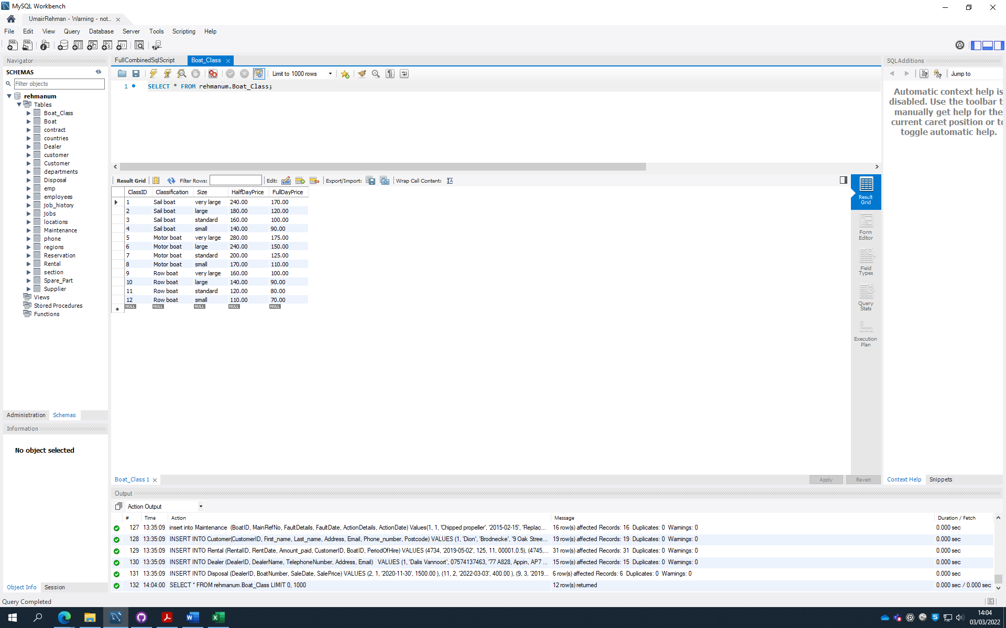

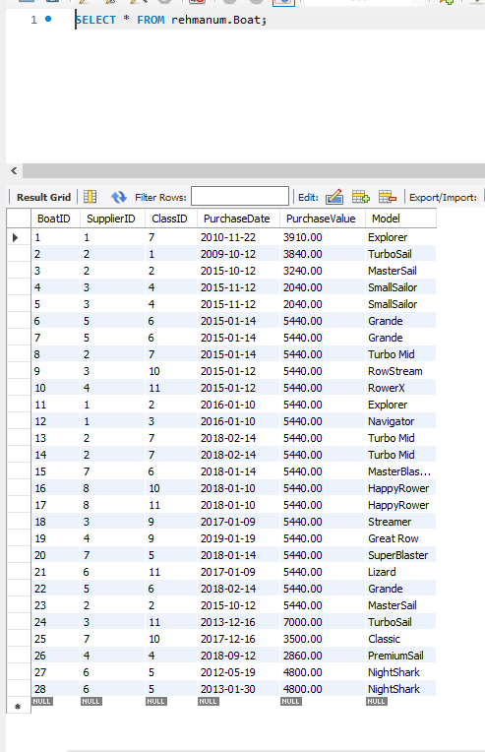

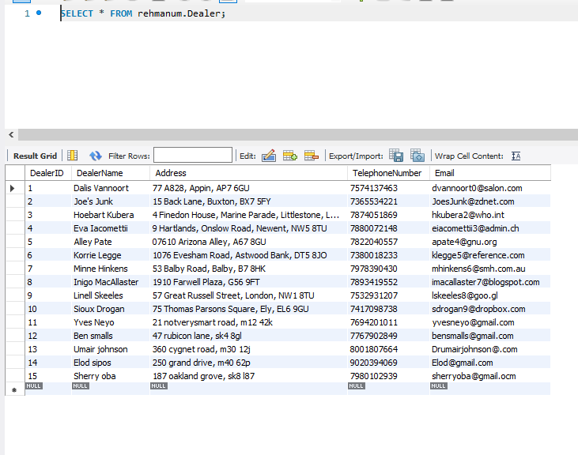

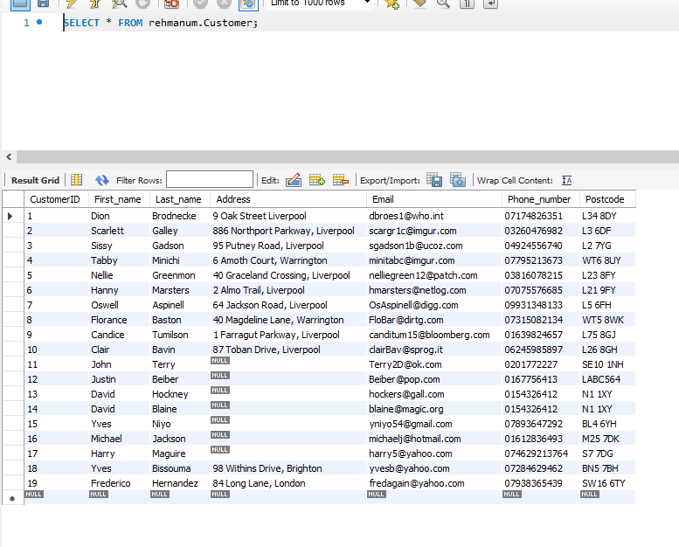

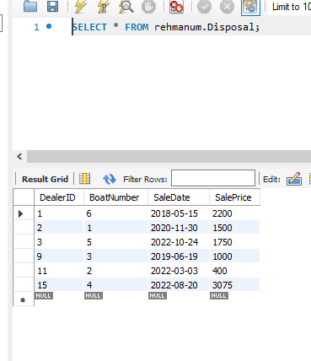

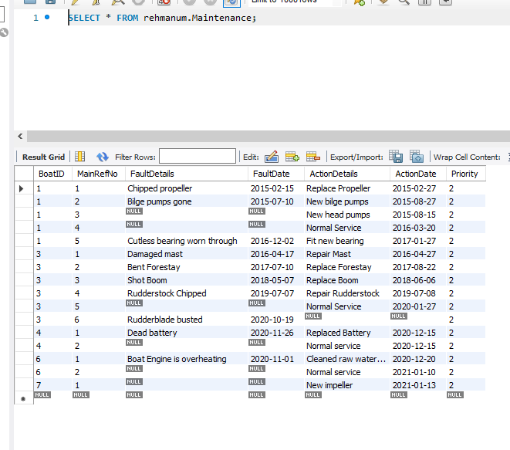

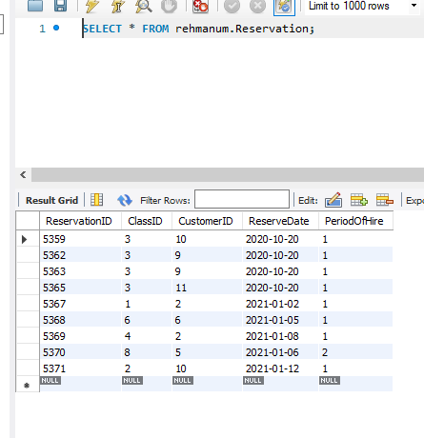

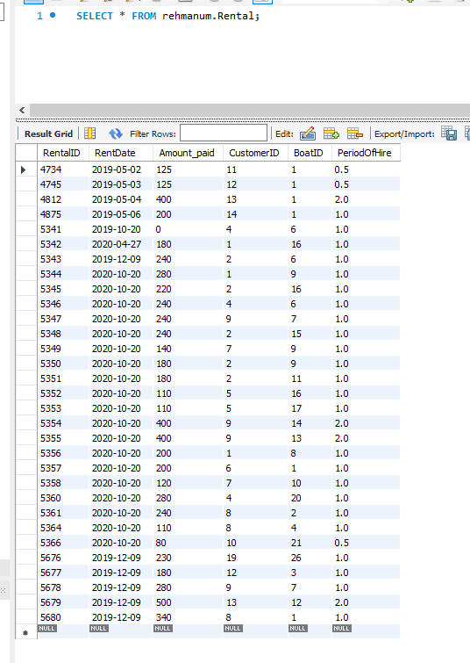

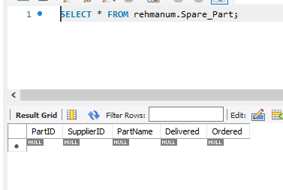

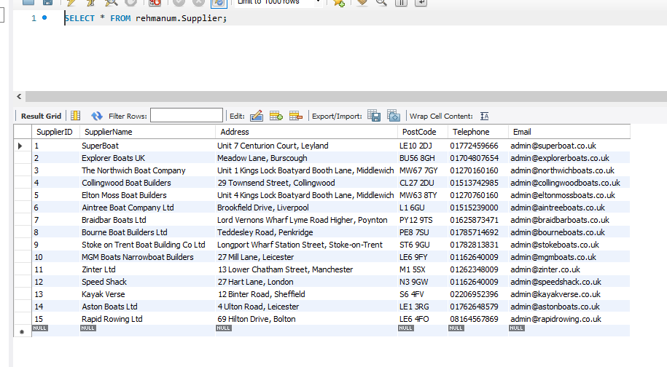

# Section 4: Student Statements

*Each team member should provide a commentary describing what they have learnt during the whole project.*

## Umair Rehman (21343766)

* Learnt how to work as a team
* Learnt how to use the application Github Desktop to collaborate with others
* Learnt how to normalise data and create a bottom up ERD

## Yves Niyo (21364033)

* I improved team working and collaborative skill working through GitHub.
* I learned how to use mySQL workbench.
* I learned creating ERDs and normalisation forms.

## Benjamin Ajayi (21361114)

* Learned to code databases in SQL
* Learned to work in a group using Github.
* I learned how the backend of applications work when storing data in databases.

## Aaron Oronsaye (21336343)

* Learned basic SQL.
* I learned the basics of how to create ERDs
* Learned how to share and access work using Github.

# Appendix A: Individual ERD Attempts

Umair Rehman (21343766)

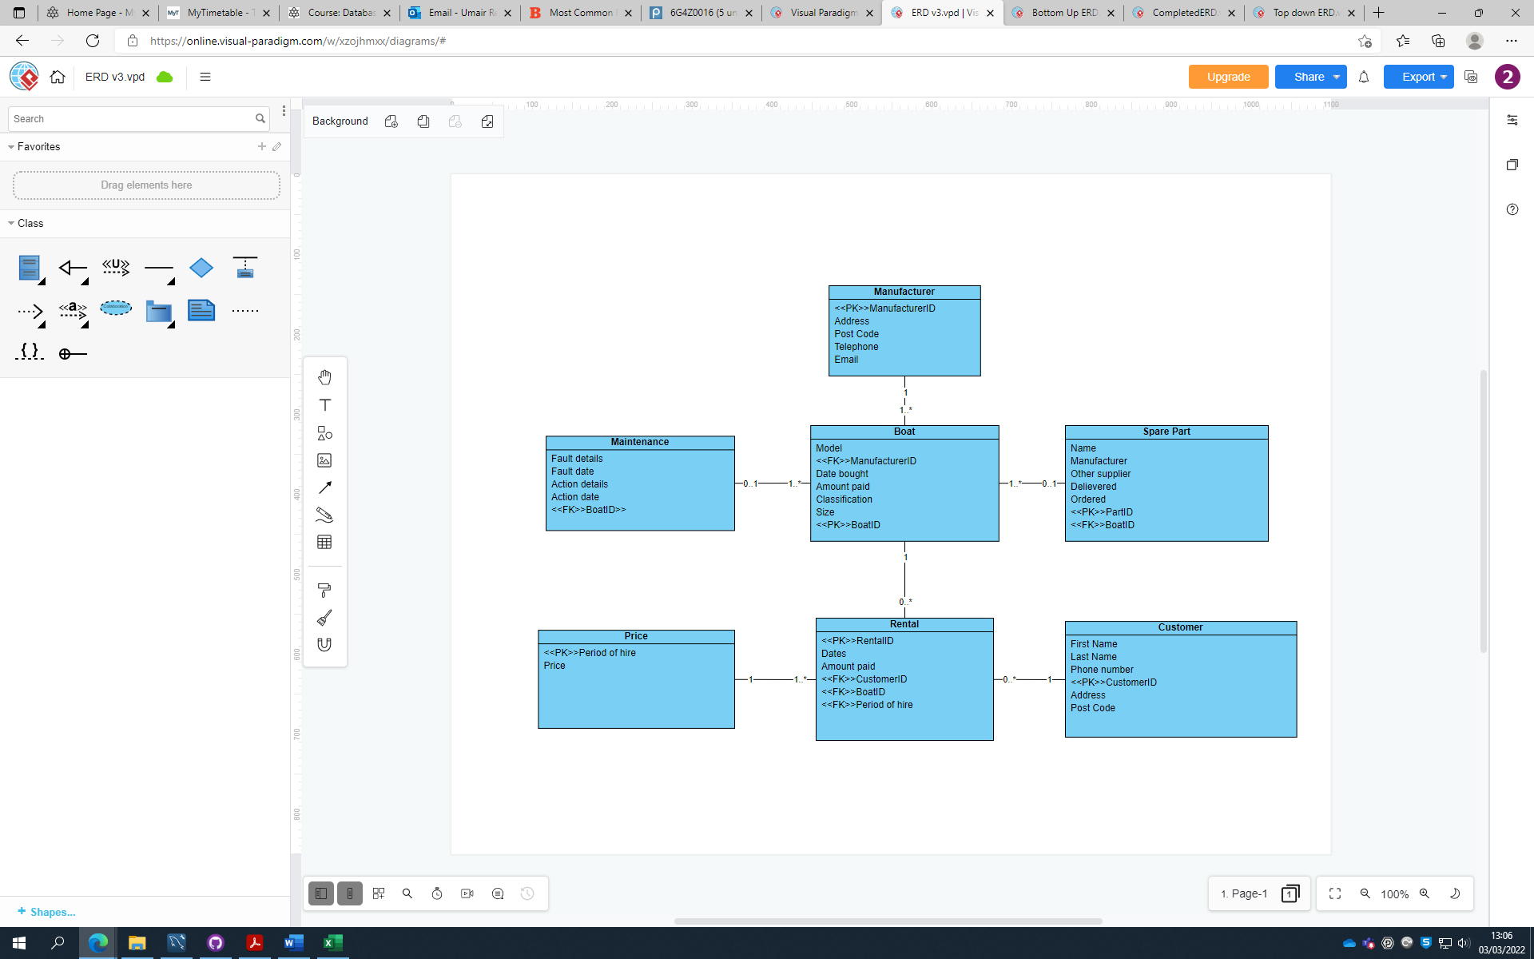

Benjamin Ajayi (21361114)

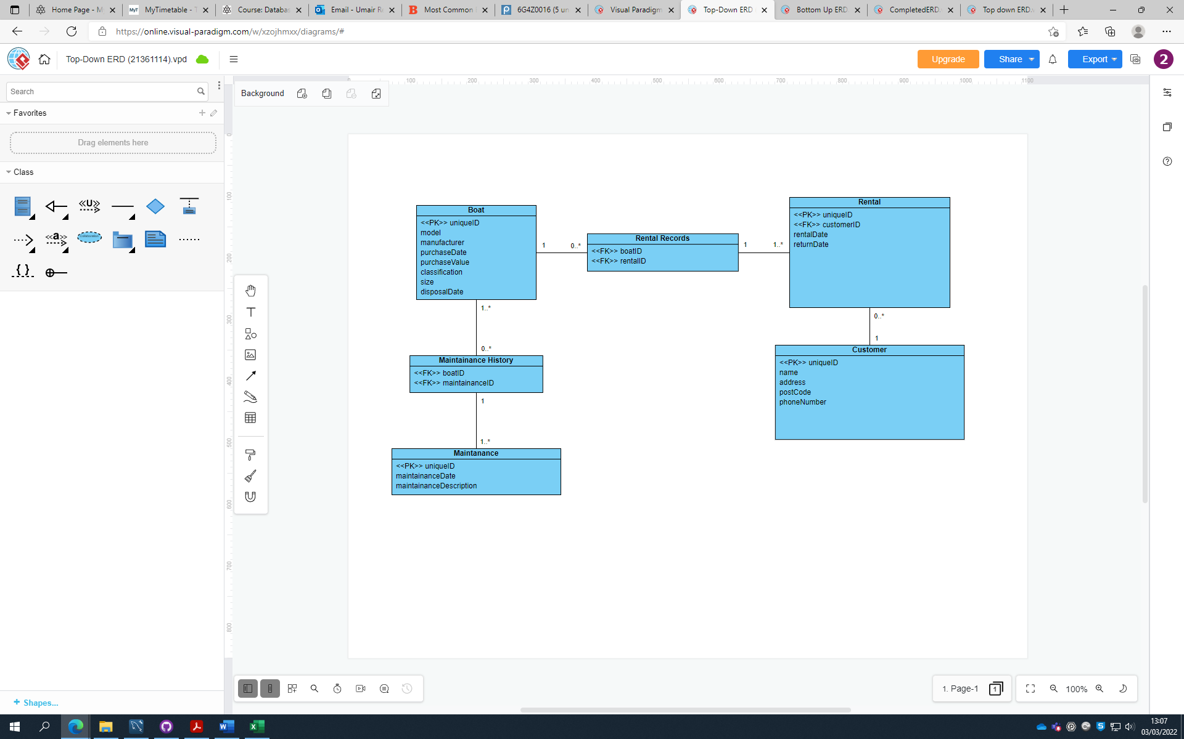

Yves Niyo (21364033)

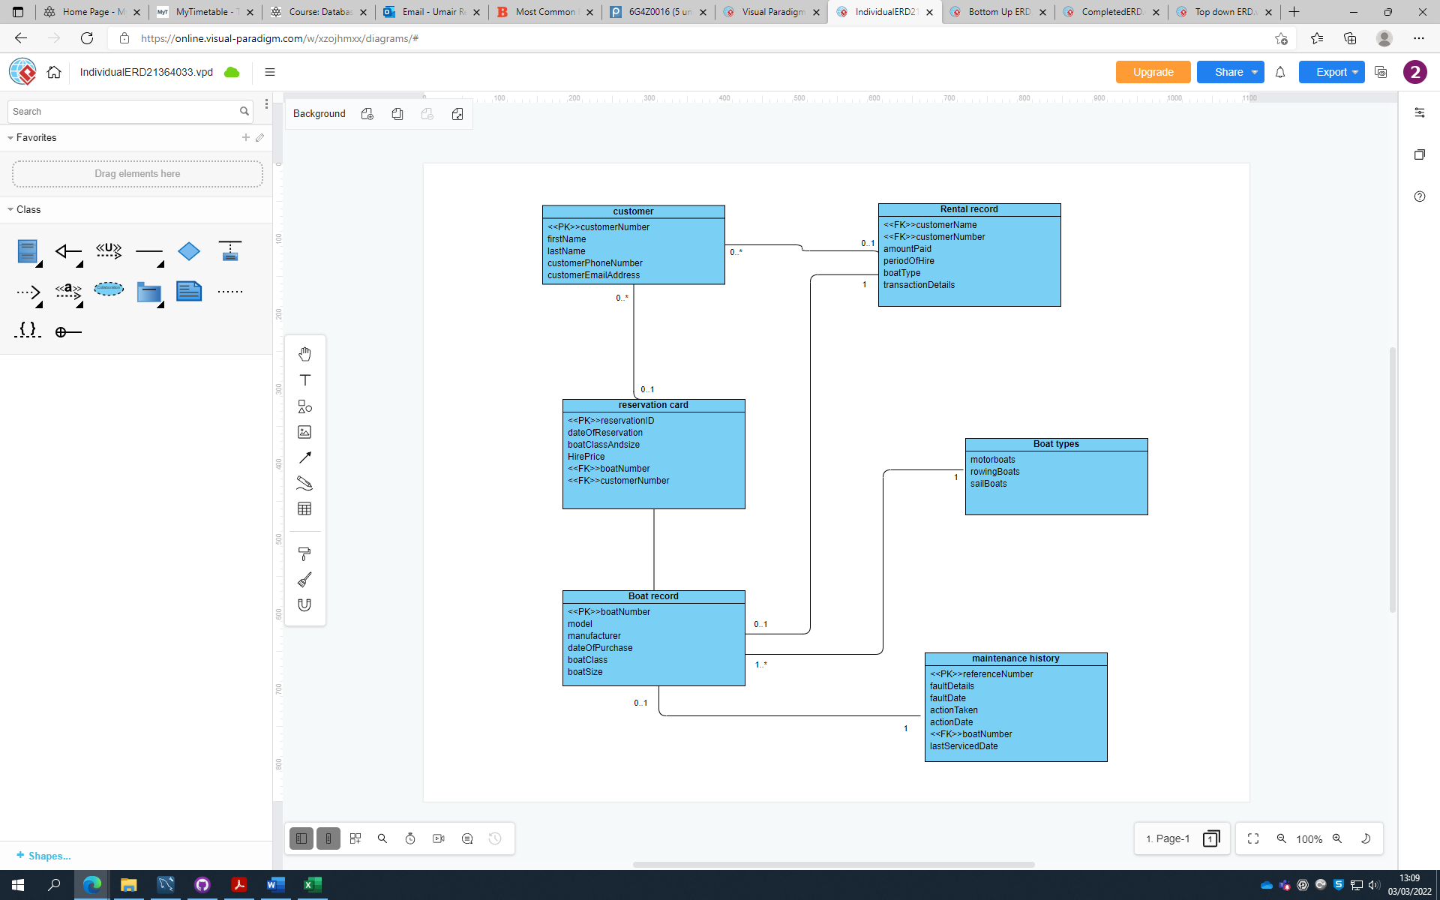

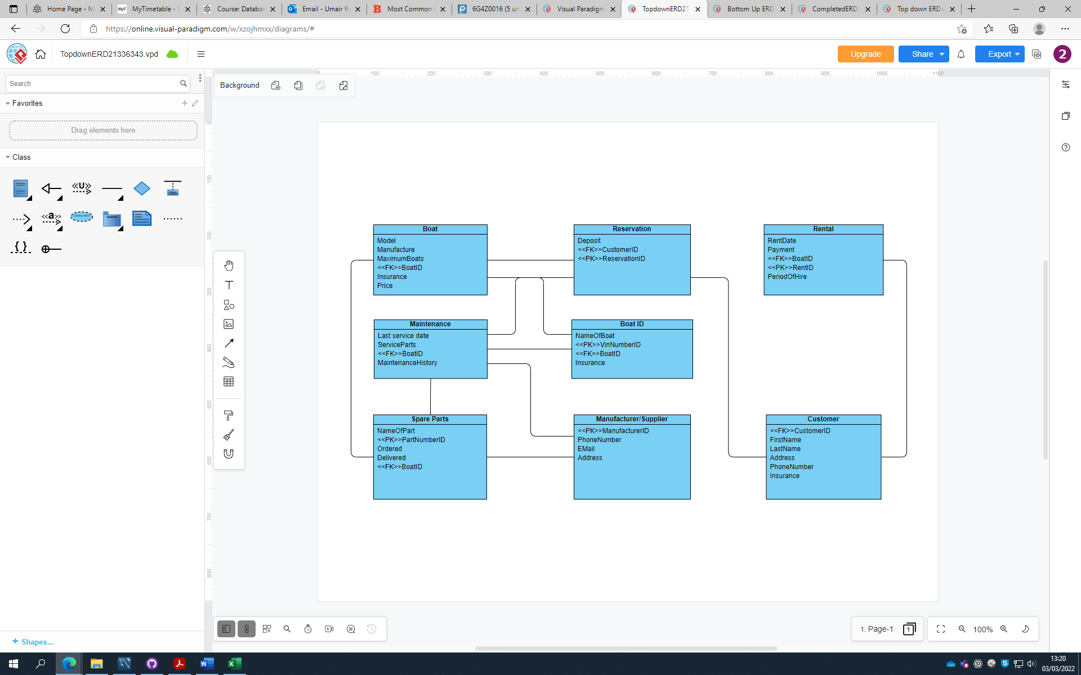Aaron Oronsaye (21336343)

# Appendix B: Logbook

*Copy and paste all of your logbook entries here*

*Each logbook should clearly display the following:*

**Date:**

**Names of those present:**

**Names of those absent:**

**What was discussed:**

**Action plan:**

Date: 26/01/22

Attendance: all attended

The first meting was to make sure everyone knew what the assignment was about and figuring out how to start. We started by independently creating our ERDs.

Will meet 2/02/22

Task for all: finish independent ERDs

Date: 09/02/22

Attendance: All but Benji

Aaron and Yves: finishing off independent ERDs

Umair: normalisation of appendix A

will meet tomorrow.

Date:10/02/22

Attendance:All

completed group top down ERD

will check with tutor

next time, will work on bottom up ERD

Date:16/02/22

Finished bottom up ERD at home

Completed joining top down and bottom up ERD in lab

we separated the tasks for creating the tables.

Yves: Customer and rental

Aaron: disposal and dealer

Benji: Boat, Manufacturer/supplier and spare part

Umair: Maintenance, boat class and reservation

02/03/22

Attendance: All

Finished all insert statements

03/03/22

Attendance: All

Added 5 extra tuple to each table

started the report

combined insert statements

# Appendix C: Full SQL Code

*Copy and paste all of your SQL code here*

/************************************************************************************************************************/

/* Drop tables (if existing) */

DROP TABLE IF EXISTS Disposal;

DROP TABLE IF EXISTS Dealer;

DROP TABLE IF EXISTS Rental;

DROP TABLE IF EXISTS Customer;

DROP TABLE IF EXISTS Reservation;

DROP TABLE IF EXISTS Maintenance;

DROP TABLE IF EXISTS Spare_Part;

DROP TABLE IF EXISTS Boat;

DROP TABLE IF EXISTS Boat_Class;

DROP TABLE IF EXISTS Supplier;

/************************************************************************************************************************/

/* Create Tables */

CREATE TABLE Supplier (

SupplierID INT PRIMARY KEY AUTO_INCREMENT,

SupplierName VARCHAR(50),

Address VARCHAR(50),

PostCode VARCHAR(8),

Telephone VARCHAR(15),

Email VARCHAR(40) UNIQUE

);

create table Boat_Class (

ClassID int primary key auto_increment,

Classification varchar(20) CHECK (Classification IN ("Motor boat", "Row boat", "Sail boat")),

Size varchar(15) CHECK (Size IN ("very large", "large", "standard", "small")),

HalfDayPrice decimal (5,2),

FullDayPrice decimal (5,2)

);

CREATE TABLE Boat (

BoatID INT PRIMARY KEY AUTO_INCREMENT,

SupplierID INT NOT NULL,

ClassID INT,

PurchaseDate DATE,

PurchaseValue DECIMAL(8, 2),

Model VARCHAR(20),

CONSTRAINT FK_BOAT_SUPPLIER_ID FOREIGN KEY (SupplierID) REFERENCES Supplier (SupplierID) ON UPDATE CASCADE,

CONSTRAINT FK_BOAT_CLASS_ID FOREIGN KEY (ClassID) REFERENCES Boat_Class (ClassID) ON UPDATE CASCADE,

CONSTRAINT PURCHASE_VALUE_CHK CHECK (PurchaseValue >= 0)

);

CREATE TABLE Spare_Part (

PartID INT PRIMARY KEY AUTO_INCREMENT,

SupplierID INT NOT NULL,

PartName VARCHAR(10),

Delivered BIT,

Ordered BIT,

CONSTRAINT FK_SPARE_PART_SUPPLIER_ID FOREIGN KEY (SupplierID) REFERENCES Supplier (SupplierID) ON UPDATE CASCADE

);

create table Reservation (

ReservationID int primary key auto_increment,

ClassID int,

CustomerID int,

ReserveDate date,

PeriodOfHire varchar(10),

constraint fk_ClassID foreign key (ClassID) references Boat_Class (ClassID) ON UPDATE CASCADE

);

create table Maintenance (

BoatID int,

MainRefNo int ,

FaultDetails varchar(100),

FaultDate date,

ActionDetails varchar(50),

ActionDate date,

Priority INT DEFAULT 2,

CONSTRAINT primary key (BoatID, MainRefNo),

CONSTRAINT FK_BOAT_ID FOREIGN KEY (BoatID) REFERENCES Boat (BoatID) ON UPDATE CASCADE

);

CREATE TABLE Customer (

CustomerID INT PRIMARY KEY,

First_name VARCHAR(45),

Last_name VARCHAR(45),

Address VARCHAR(45),

Email VARCHAR(45),

Phone_number varchar(15),

Postcode VARCHAR(45)

);

CREATE TABLE Rental (

RentalID INT PRIMARY KEY,

RentDate DATE,

Amount_paid INT,

CustomerID INT,

BoatID INT,

PeriodOfHire DECIMAL(3,1),

CONSTRAINT customer_renting FOREIGN KEY (customerID) REFERENCES Customer(customerID),

CONSTRAINT boat_key FOREIGN KEY(BoatID) REFERENCES Boat (BoatID)

);

create table Dealer (

DealerID int primary key auto_increment,

DealerName varchar(50),

Address varchar(100),

TelephoneNumber varchar(15),

Email varchar(100)

);

create table Disposal (

DealerID int,

BoatNumber int,

SaleDate date,

SalePrice int,

CONSTRAINT primary key (DealerID, BoatNumber),

constraint fk_DealerID foreign key (DealerID) references Dealer (DealerID) ON UPDATE CASCADE

);

/************************************************************************************************************************/

INSERT INTO Supplier (SupplierID, SupplierName, Address, PostCode, Telephone, Email) VALUES

(1, "SuperBoat", "Unit 7 Centurion Court, Leyland", "LE10 2DJ", "01772459666", "admin@superboat.co.uk"),

(2, "Explorer Boats UK", "Meadow Lane, Burscough", "BU56 8GH", "01704807654", "admin@explorerboats.co.uk"),

(3, "The Northwich Boat Company", "Unit 1 Kings Lock Boatyard Booth Lane, Middlewich", "MW67 7GY", "01270160160", "admin@northwichboats.co.uk"),

(4, "Collingwood Boat Builders", "29 Townsend Street, Collingwood", "CL27 2DU", "01513742985", "admin@collingwoodboats.co.uk"),

(5, "Elton Moss Boat Builders", "Unit 4 Kings Lock Boatyard Booth Lane, Middlewich", "MW63 8TY", "01270760160", "admin@eltonmossboats.co.uk"),

(6, "Aintree Boat Company Ltd", "Brookfield Drive, Liverpool", "L1 6GU", "01515239000", "admin@aintreeboats.co.uk"),

(7, "Braidbar Boats Ltd", "Lord Vernons Wharf Lyme Road Higher, Poynton", "PY12 9TS", "01625873471", "admin@braidbarboats.co.uk"),

(8, "Bourne Boat Builders Ltd", "Teddesley Road, Penkridge", "PE8 7SU", "01785714692", "admin@bourneboats.co.uk"),

(9, "Stoke on Trent Boat Building Co Ltd", "Longport Wharf Station Street, Stoke-on-Trent", "ST6 9GU", "01782813831", "admin@stokeboats.co.uk"),

(10, "MGM Boats Narrowboat Builders", "27 Mill Lane, Leicester", "LE6 9FY", "01162640009", "admin@mgmboats.co.uk"),

(11, "Zinter Ltd", "13 Lower Chatham Street, Manchester", "M1 5SX", "01262348009", "admin@zinter.co.uk"),

(12, "Speed Shack", "27 Hart Lane, London", "N3 9GW", "01162640009", "admin@speedshack.co.uk"),

(13, "Kayak Verse", "12 Binter Road, Sheffield", "S6 4FV", "02206952396", "admin@kayakverse.co.uk"),

(14, "Aston Boats Ltd", "4 Ulton Road, Leicester", "LE1 3RG", "01762648579", "admin@astonboats.co.uk"),

(15, "Rapid Rowing Ltd", "69 Hilton Drive, Bolton", "LE6 4FO", "08164567869", "admin@rapidrowing.co.uk");

Insert into Boat_Class

(ClassID, Classification, Size, HalfDayPrice, FullDayPrice)

Values (1, 'Sail boat', 'very large', 240, 170),

(2, 'Sail boat', 'large', 180, 120),

(3, 'Sail boat', 'standard', 160, 100),

(4, 'Sail boat', 'small', 140, 90),

(5, 'Motor boat', 'very large', 280, 175),

(6, 'Motor boat', 'large', 240, 150),

(7, 'Motor boat', 'standard', 200, 125 ),

(8, 'Motor boat', 'small', 170, 110),

(9, 'Row boat', 'very large', 160, 100),

(10, 'Row boat', 'large', 140, 90),

(11, 'Row boat', 'standard', 120, 80 ),

(12, 'Row boat', 'small', 110, 70);

INSERT INTO Boat (BoatID, SupplierID, ClassID, PurchaseDate, PurchaseValue, Model) VALUES

(1, 1, 7, "2010-11-22", 3910, "Explorer"),

(2, 2, 1, "2009-10-12", 3840, "TurboSail"),

(3, 2, 2, "2015-10-12", 3240, "MasterSail"),

(4, 3, 4, "2015-11-12", 2040, "SmallSailor"),

(5, 3, 4, "2015-11-12", 2040, "SmallSailor"),

(6, 5, 6, "2015-01-14", 5440, "Grande"),

(7, 5, 6, "2015-01-14", 5440, "Grande"),

(8, 2, 7, "2015-01-14", 5440, "Turbo Mid"),

(9, 3, 10, "2015-01-12", 5440, "RowStream"),

(10, 4, 11, "2015-01-12", 5440, "RowerX"),

(11, 1, 2, "2016-01-10", 5440, "Explorer"),

(12, 1, 3, "2016-01-10", 5440, "Navigator"),

(13, 2, 7, "2018-02-14", 5440, "Turbo Mid"),

(14, 2, 7, "2018-02-14", 5440, "Turbo Mid"),

(15, 7, 6, "2018-01-14", 5440, "MasterBlaster"),

(16, 8, 10, "2018-01-10", 5440, "HappyRower"),

(17, 8, 11, "2018-01-10", 5440, "HappyRower"),

(18, 3, 9, "2017-01-09", 5440, "Streamer"),

(19, 4, 9, "2019-01-19", 5440, "Great Row"),

(20, 7, 5, "2018-01-14", 5440, "SuperBlaster"),

(21, 6, 11, "2017-01-09", 5440, "Lizard"),

(22, 5, 6, "2018-02-14", 5440, "Grande"),

(23, 2, 2, "2015-10-12", 5440, "MasterSail"),

(24, 3, 11, "2013-12-16", 7000, "TurboSail"),

(25, 7, 10, "2017-12-16", 3500, "Classic"),

(26, 4, 4, "2018-09-12", 2860, "PremiumSail"),

(27, 6, 5, "2012-05-19", 4800, "NightShark"),

(28, 6, 5, "2013-01-30", 4800, "NightShark");

insert into Reservation

(ReservationID, ClassID, CustomerID, ReserveDate, PeriodOfHire)

Values(5359, 3, 10, '2020-10-20', 1),

(5362, 3, 9, '2020-10-20', 1),

(5365, 3, 11, '2020-10-20', 1),

(5363, 3, 9, '2020-10-20', 1),

(5367, 1, 2, '2021-01-2', 1),

(5368, 6, 6, '2021-01-5', 1),

(5369, 4, 2, '2021-01-8', 1),

(5370, 8, 5, '2021-01-6', 2),

(5371, 2, 10, '2021-01-12', 1);

insert into Maintenance

(BoatID, MainRefNo, FaultDetails, FaultDate, ActionDetails, ActionDate)

Values(1, 1, 'Chipped propeller', '2015-02-15', 'Replace Propeller', '2015-02-27'),

(1, 2, 'Bilge pumps gone', '2015-07-10', 'New bilge pumps', '2015-08-27'),

(1, 3, Null, Null, 'New head pumps', '2015-08-15'),

(1, 4, Null, Null, 'Normal Service', '2016-03-20'),

(1, 5, 'Cutless bearing worn through', '2016-12-02', 'Fit new bearing', '2017-01-27'),

(3, 1, 'Damaged mast', '2016-04-17', 'Repair Mast', '2016-04-27'),

(3, 2, 'Bent Forestay', '2017-07-10', 'Replace Forestay', '2017-08-22'),

(3, 3, 'Shot Boom', '2018-05-07', 'Replace Boom', '2018-06-06'),

(3, 4, 'Rudderstock Chipped', '2019-07-07', 'Repair Rudderstock', '2019-07-08'),

(3, 5, Null, Null, 'Normal Service', '2020-01-27'),

(3, 6, 'Rudderblade busted', '2020-10-19', Null, Null),

(4, 1, 'Dead battery', '2020-11-26', 'Replaced Battery', '2020-12-15'),

(4, 2, Null, Null, 'Normal service', '2020-12-15'),

(6, 1, 'Boat Engine is overheating', '2020-11-1', 'Cleaned raw water intake', '2020-12-20'),

(6, 2, Null, Null, 'Normal service', '2021-01-10'),

(7, 1, Null, Null, 'New impeller', '2021-01-13');

INSERT INTO Customer(CustomerID, First_name, Last_name, Address, Email, Phone_number, Postcode)

VALUES (1, 'Dion', 'Brodnecke', '9 Oak Street Liverpool', 'dbroes1@who.int', '07174826351', 'L34 8DY'),

(2, 'Scarlett', 'Galley', '886 Northport Parkway, Liverpool', 'scargr1c@imgur.com', '03260476982', 'L3 6DF'),

(3, 'Sissy', 'Gadson', '95 Putney Road, Liverpool', 'sgadson1b@ucoz.com', '04924556740', 'L2 7YG'),

(4, 'Tabby', 'Minichi', '6 Amoth Court, Warrington', 'minitabc@imgur.com', '07795213673', 'WT6 8UY'),

(5, 'Nellie', 'Greenmon', '40 Graceland Crossing, Liverpool', 'nelliegreen12@patch.com', '03816078215', 'L23 8FY'),

(6, 'Hanny', 'Marsters', '2 Almo Trail, Liverpool', 'hmarsters@netlog.com', '07075576685', 'L21 9FY'),

(7, 'Oswell', 'Aspinell', '64 Jackson Road, Liverpool', 'OsAspinell@digg.com', '09931348133', 'L5 6FH'),

(8, 'Florance', 'Baston', '40 Magdeline Lane, Warrington', 'FloBar@dirtg.com', '07315082134', 'WT5 8WK'),

(9, 'Candice', 'Tumilson', '1 Farragut Parkway, Liverpool', 'canditum15@bloomberg.com', '01639824657', 'L75 8GJ'),

(10, 'Clair', 'Bavin', '87 Toban Drive, Liverpool', 'clairBav@sprog.it', '06245985897', 'L26 8GH'),

(11, 'John', 'Terry', null, 'Terry2D@ok.com', '0201772227', 'SE10 1NH'),

(12, 'Justin', 'Beiber', null, 'Beiber@pop.com', '0167756413', 'LABC564' ),

(13, 'David', 'Hockney', null, 'hockers@gall.com', '0154326412', 'N1 1XY'),

(14, 'David', 'Blaine', null, 'blaine@magic.org', '0154326412', 'N1 1XY'),

(15, 'Yves', 'Niyo', null, 'yniyo54@gmail.com', '07893647292','BL4 6YH'),

(16, 'Michael', 'Jackson', null, 'michaelj@hotmail.com', '01612836493', 'M25 7DK'),

(17, 'Harry', 'Maguire', null, 'harry5@yahoo.com', '074629213764', 'S7 7DG'),

(18, 'Yves', 'Bissouma','98 Withins Drive, Brighton', 'yvesb@yahoo.com' ,'07284629462', 'BN5 7BH'),

(19, 'Frederico', 'Hernandez', '84 Long Lane, London', 'fredagain@yahoo.com','07938365439', 'SW16 6TY');

INSERT INTO Rental (RentalID, RentDate, Amount_paid, CustomerID, BoatID, PeriodOfHire)

VALUES (4734, '2019-05-02', 125, 11, 00001,0.5),

(4745, '2019-05-03', 125, 12, 00001,0.5),

(4812, '2019-05-04', 400, 13, 00001,2),

(4875, '2019-05-06', 200, 14, 00001,1),

(5344, '2020-10-20', 280, 1, 9, 1),

(5345, '2020-10-20', 220, 2, 16, 1),

(5347, '2020-10-20', 240, 9, 7, 1),

(5346, '2020-10-20', 240, 4, 6, 1),

(5349, '2020-10-20', 140, 7, 9, 1),

(5348, '2020-10-20', 240, 2, 15,1),

(5350, '2020-10-20', 180, 2, 9, 1),

(5352, '2020-10-20', 110, 5, 16, 1),

(5353, '2020-10-20', 110, 5, 17, 1),

(5354, '2020-10-20', 400, 9, 14, 2),

(5351, '2020-10-20', 180, 2, 11, 1),

(5364, '2020-10-20', 110, 8, 4, 1),

(5355, '2020-10-20', 400, 9, 13, 2),

(5356, '2020-10-20', 200, 1, 8, 1),

(5357, '2020-10-20', 200, 6, 1, 1),

(5358, '2020-10-20', 120, 7, 10, 1),

(5366, '2020-10-20', 80, 10, 21, 0.5),

(5360, '2020-10-20', 280, 4, 20, 1),

(5361, '2020-10-20', 240, 8, 2, 1),

(5342, '2020-04-27', 180, 1, 16, 1),

(5341, '2019-10-20', 0, 4, 6, 1),

(5343, '2019-12-09', 240, 2, 6, 1),

(5676, '2019-12-09', 230, 19,26, 1),

(5677, '2019-12-09', 180, 12,3, 1),

(5678, '2019-12-09', 280, 9,7, 1),

(5679, '2019-12-09', 500, 13,12, 2),

(5680, '2019-12-09', 340, 8,1, 1);

INSERT INTO Dealer (DealerID, DealerName, TelephoneNumber, Address, Email)

VALUES (1, 'Dalis Vannoort', 07574137463, '77 A828, Appin, AP7 6GU', 'dvannoort0@salon.com'),

(2, "Joe's Junk", 07365534221, '15 Back Lane, Buxton, BX7 5FY', 'JoesJunk@zdnet.com'),

(3, 'Hoebart Kubera', 07874051869, '4 Finedon House, Marine Parade, Littlestone, LS4 6GU', 'hkubera2@who.int'),

(4, 'Eva Iacomettii', 07880072148, '9 Hartlands, Onslow Road, Newent, NW5 8TU', 'eiacomettii3@admin.ch'),

(5, 'Alley Pate', 07822040557, '07610 Arizona Alley, A67 8GU', 'apate4@gnu.org'),

(6, 'Korrie Legge', 07380018233, '1076 Evesham Road, Astwood Bank, DT5 8JO', 'klegge5@reference.com'),

(7, 'Minne Hinkens', 07978390430, '53 Balby Road, Balby, B7 8HK', 'mhinkens6@smh.com.au'),

(8, 'Inigo MacAllaster', 07893419552, '1910 Farwell Plaza, G56 9FT', 'imacallaster7@blogspot.com'),

(9, 'Linell Skeeles', 07532931207, '57 Great Russell Street, London, NW1 8TU', 'lskeeles8@goo.gl'),

(10, 'Sioux Drogan', 07417098738, '75 Thomas Parsons Square, Ely, EL6 9GU', 'sdrogan9@dropbox.com'),

(11, 'Yves Neyo', 07694201011, '21 notverysmart road, m12 42k', 'yvesneyo@gmail.com' ),

(12, 'Ben smalls', 07767902849, '47 rubicon lane, sk4 8gl', 'bensmalls@gmail.com'),

(13, 'Umair johnson', 08001807664, '360 cygnet road, m30 12j', 'Drumairjohnson@.com'),

(14, 'Elod sipos', 09020394069, '250 grand drive, m40 62p', 'Elod@gmail.com'),

(15, 'Sherry oba', 07980102939, '187 oakland grove, sk8 l87', 'sherryoba@gmail.ocm')

;

INSERT INTO Disposal (DealerID, BoatNumber, SaleDate, SalePrice)

VALUES (2, 1, '2020-11-30', 1500.00 ),

(11, 2, '2022-03-03', 400.00 ),

(9, 3, '2019-06-19', 1000.00 ),

(15, 4, '2022-08-20', 3075.00),

(3, 5, '2022-10-24', 1750.00),

(1, 6, '2018-05-15', 2200.00)

;